

**KABARAK UNIVERSITY**

**SCHOOL OF SCIENCE ENGINEERING AND TECHNOLOGY**

**DEPARTMENT OF COMPUTER SCIENCE AND INFORMATION TECHNOLOGY**

**BACHELOR OF BUSINESS IN INFORMATION TECHNOLOGY**

**TITLE: COURSE MATERIAL REPOSITORY APP**

**PRESENTED BY:**

**Victor Murage Mwangi BMIT/MG/2250/09/21**

**Github Link:**

**A Research Project Submitted to The School of Science Engineering and Technology In Partial Fulfillment Of The Requirement For The Award Of The Degree In Bachelor Of Business in Information Technology, Kabarak University**.

## COPYRIGHT

© 2024

All Rights Reserved

No part of this project may be reproduced, stored in any retrieval system, or transmitted in any form or by any means, electronic, mechanical, photocopying, or recording without prior written permission of the author or Kabarak University.

Sign: ________________________ Date: ________________________

## **DECLARATION AND APPROVAL**

I declare that this project proposal titled” Kabarak Finance System” is my original work and has never been presented elsewhere for any academic or professional purpose or any other Institution. This research document shall therefore not be duplicated without consent.

Approved as to content, quality, and presentation by:

Victor Murage Mwangi BMIT/MG/2456/09/21

Sign: ___________________ Date: _________________

## **RECOMMENDATION**

This research proposal titled Kabarak Finance System by Victor Murage Mwangi, is presented to the School of Science, Engineering, and Technology of Kabarak University. I have reviewed this project and recommended it will be accepted in partial fulfillment of the requirements for the Bachelor of Business and Information Technology.

Signature ……………………………………… Date …………………………….

**Cleophas Mochoge**

**School of Science, Engineering, and Technology**

**Department of Computer Science and Information Technology**

**Kabarak University**

## 

## **ACKNOWLEDGEMENT**

I would like to thank God for the far He has brought me and for the gift of life, family and friends for without them I would not have been able to achieve the much that I have in my academic pursuit. Their unwavering support and understanding have really been a great support through this journey.

Additionally, I would like to express my heartfelt gratitude to my supervisor, for the invaluable guidance, support, and encouragement throughout our studies. Your insightful feedback and expertise have been instrumental in shaping the direction and quality of this work.

## **DEDICATION**

This project is dedicated to my family, whose unwavering support and encouragement have been my greatest source of strength. Their belief in my abilities has motivated me to strive for excellence. I also dedicate this work to my mentors, friends and educators whose guidance and wisdom have profoundly shaped my academic journey. Thank you for your inspiration and support.

## **Abstract**

This project presents the development and implementation of the **Kabarak Finance System**, a web-based financial management application aimed at automating and streamlining the key financial operations at Kabarak University. The system was conceived to address critical challenges arising from the university's continued reliance on manual processes for handling student fee payments, generating receipts, tracking balances, and producing financial reports. These manual methods, while traditional, have proven inefficient due to issues such as delayed processing, human error, missing or inaccurate records, poor accessibility to real-time data, and lack of transparency. The purpose of the Kabarak Finance System is to eliminate these inefficiencies by digitizing the financial workflows and providing a centralized platform that enhances user experience, increases data accuracy, improves accountability, and ensures timely financial reporting.

The main objective of the project is to design and develop a secure, responsive, and scalable system that supports finance officers and students in executing and managing financial transactions digitally. The system allows students to register, view their payment history, check current balances, download receipts, and receive real-time notifications on financial activities. For administrators and finance staff, the system provides tools for managing user accounts, updating fee structures, generating real-time financial reports, tracking payments, and performing audits. Additional features include login authentication, role-based access control, automated reporting, and backup functionalities to ensure data integrity and system security.

The project employed the **Agile software development methodology**, enabling iterative development, continuous stakeholder feedback, and adaptive planning throughout the system’s lifecycle. System requirements were gathered through interviews and observation, and the final solution was modeled using various software design tools including **Data Flow Diagrams (DFDs)**, **Entity-Relationship Diagrams (ERDs)**, and **flowcharts** to represent the architecture and logic behind the system. The system was developed using open-source technologies including **PHP** for server-side scripting, **MySQL** for the relational database, and **HTML**, **CSS**, and **JavaScript** for front-end design and responsiveness.

This project not only demonstrates the practical application of classroom-acquired knowledge and programming skills but also serves as a foundation for future innovations in financial automation within higher learning institutions. It contributes to the university’s ongoing digital transformation efforts and provides a replicable model for other institutions aiming to modernize their financial systems. The Kabarak Finance System stands as a functional, impactful, and future-ready solution to the complex needs of financial management in academic institutions.

# **CONTENTS**

# COPYRIGHT……………………………………………………………………………………II DECLARATION AND APPROVAL……………………………………………………… III RECOMMENDATION……………………………………………………………………. IV ACKNOWLEDGEMENT ……………………………………………………………….V DEDICATION ………………………………………………………………………….VI ABSTRACT …………………………………………………………………………….VII

# **CHAPTER ONE: INTRODUCTION…………………………………………………………..** 1

# 1.0 Introduction……………………………………………………………………………….. 1 1.1 Background to the Study………………………………………………………………… 2 1.2 Statement of the Problem………………………………………………………………… 4 1.3 Purpose of the Study………………………………………………………………… 5 1.4 Main Objective………………………………………………………………… 5 1.4.1 General Objective………………………………………………………………… 5 1.4.2 Specific Objectives………………………………………………………………… 5 1.5 Research Questions………………………………………………………………… 6 1.6 Proposed System………………………………………………………………… 6 1.7 System Modules …………………………………………………………………7 1.8 Justification of the Study………………………………………………………………… 8 1.9 Feasibility Study………………………………………………………………… 9 1.10 Scope and Limitations of theStudy……………………………………………………… 10

# **CHAPTER TWO: LITERATURE REVIEW** ……………………………………………… 11

# 2.0 Introduction………………………………………………………………… 11 2.1 Review of Objective One: Automating Financial Transactions………………………… 12 2.2 Review of Objective Two: Enhancing System Security………………………… 13 2.3 Review of Objective Three: Improving User Interface and Experience………………… 14 2.4 Conceptual Framework…………………………………………………………………… 15

# **CHAPTER THREE: RESEARCH DESIGN AND METHODOLOGY**………………… 16

# 3.0 Research Design Methods…………………………………………………… 16 3.1 Location of the Study…………………………………………………… 16 3.2 Population of the Study…………………………………………………… 16 3.3 Sampling Procedure and Sample Size…………………………………………………… 17 3.4 Data Collection Procedure…………………………………………………… 17 3.5 System Development Methodology…………………………………………………… 18 3.6 System Analysis and Design…………………………………………………… 18 Design Diagrams……………………………………………………………………………… 20 Context Diagram……………………………………………………………………………… 20 Architectural Design………………………………………………………………………… 21 Database Design……………………………………………………………………………… 22 Use Case Diagram…………………………………………………………………………… 23 Data Flow Diagram…………………………………………………………………………… 24 Ethical Considerations……………………………………………………………………… 25

# **CHAPTER FOUR: SYSTEM IMPLEMENTATION AND DEPLOYMENT**……………… 26

# 4.0 Introduction……………………………………………………………………………… 26 4.1 System Architecture……………………………………………………………………… 26 4.1.1 Development Environment…………………………………………………… 27 4.1.2 Front-End Development………………………………………………………………… 27 4.1.3 Back-End Development………………………………………………………………… 28 4.1.4 Data Layer……………………………………………………………………………… 29 4.2 Testing and Quality Assurance…………………………………………………………… 30 4.2.1 Testing Strategy……………………………………………………………………… 30 4.2.2 QA Measures and Tools………………………………………………………………… 31 4.3 Deployment Plan……………………………………………………………………… 32 4.4 Go-Live Plan……………………………………………………………………………… 32 4.5 Maintenance and Support……………………………………………………………… 33 4.6 Conclusion and Future Work…………………………………………………… 34

# **CHAPTER FIVE: SUMMARY, CONCLUSION AND RECOMMENDATIONS**………… 35

# 5.1 Introduction……………………………………………………………………………… 35 5.2 Summary of Key Findings……………………………………………………………… 35 5.3 Conclusion……………………………………………………………………………… 36 5.4 Recommendations……………………………………………………………………… 37 5.5 Suggestions for Future Work…………………………………………………………… 38

# **REFERENCES**……………………………………………………………………………… 39

# **APPENDICES**………………………… 40

# Appendix I – Budget………………………… 40 Appendix II – Data Collection Tools………………………… 41 Appendix III – Gantt Chart………………………… 42 Appendix IV – Screenshots and Code Snippets………………………… 43

***CHAPTER ONE:INTRODUCTION***

# 1.1 Introduction

The financial management system at Kabarak University is a crucial aspect of student life, influencing their ability to handle finances efficiently and without unnecessary stress. However, the current system is marred by numerous inefficiencies, including slow processing times, frequent errors, and lack of mobile accessibility. These issues not only cause long queues and wait times but also disrupt students' academic and extracurricular activities. The Kabarak Finance System aims to address these problems by introducing a streamlined, efficient, and reliable platform for managing financial transactions.

### **1.2 Background to the Study**

Financial management systems are fundamental for ensuring smooth operations in educational institutions and providing students with a seamless experience (Nyamiaka, 2015). At **Kabarak University**, the current financial system is outdated, characterized by frequent errors, poor mobile usability, and slow responsiveness. These issues have led to increased frustration among students and overburdened the IT support team (Fiawoo et al., 2021).

The inefficiencies in the existing system disrupt students’ academic and extracurricular activities, resulting in long queues and delays in transaction processing. The repetitive system failures divert IT resources from critical improvements to continually addressing technical faults, highlighting the urgent need for a more robust and modern financial platform (Salim, 2023).

This study proposes the implementation of the **Kabarak Finance System**, a web‑based financial solution that leverages current technologies to improve user experience, ensure mobile accessibility, reduce transaction errors, and offer real-time payment processing. It seeks to introduce features such as secure payment gateways, responsive and intuitive interfaces, and two‑step student authentication, significantly enhancing operational effectiveness (Moertini et al., 2011; Kyaw Zay Oo, 2019).

Mobile accessibility is a priority in the proposed system. The platform will be fully responsive and integrated into the university’s student portal, allowing on‑ and off‑campus access from smartphones or tablets—promoting convenience and reducing dependence on physical visits to finance offices (Fiawoo et al., 2021; Yang & Wen, 2020).

The system will consist of several critical modules:

* **Transaction Processing Module**: Enables real-time payments, transfers, and account updates, eliminating delays in financial activities (Fiawoo et al., 2021).
* **User Interface Module**: Ensures ease of navigation and usability through structured, clear, and accessible design elements.
* **Security Module**: Protects user data using encryption techniques, secure gateways, and two-step verification to prevent unauthorized access and fraud (Solat, 2017; Kyaw Zay Oo, 2019).
* **Mobile Accessibility Module**: Supports compatibility across browsers and mobile platforms through responsive design and flexible interface architecture (Yang & Wen, 2020).
* **Error Handling Module**: Incorporates logging, diagnostics, and automatic alerts to detect and resolve system issues promptly, enhancing system stability and reducing IT intervention.

A study conducted in Kenyan universities found that implementing e-payment systems substantially reduced operational risks by minimizing fraudulent activities, improving record accuracy, and increasing transparency in financial transactions (Nyamiaka, 2015). Meanwhile, design frameworks in Indonesian universities revealed that robust planning and risk mitigation are critical for successful tuition payment system implementations (Moertini et al., 2011).

In summary, the limitations of the existing system at Kabarak University — including frequent errors, poor usability, and lack of mobile support — necessitate a modern and secure financial platform. The Kabarak Finance System aims to revolutionize financial operations, reduce manual burdens, streamline payment workflows, and enhance service quality for students and staff alike, aligning with institutional goals for digital transformation and operational efficiency (Salim, 2023; Fiawoo et al., 2021).

# 1.3 Statement of the Problem

The current financial management system at Kabarak University is plagued by numerous inefficiencies and errors, severely hampering the ability of students to manage their finances effectively. Issues such as slow processing times, frequent system errors, and lack of mobile accessibility lead to long queues and extended wait times for transaction processing. This disrupts students' academic and extracurricular activities and generates excessive workload for the IT support team, who must constantly address recurring problems. There is an urgent need for a comprehensive solution to these challenges, providing a reliable, efficient, and user-friendly financial management system for all students.

# 1.4 Objectives of the Study

The purpose of this study is to develop and implement a reliable and efficient financial management system that addresses the current system's inefficiencies. By leveraging modern technology, the new system aims to enhance the overall financial management experience for students at Kabarak University, ensuring smooth, secure, and accessible financial operations.

## 1.4.1 Main Objective

To develop a reliable and efficient financial management system that significantly enhances the overall experience for students at Kabarak University. This system aims to reduce inefficiencies and operational errors by leveraging modern technology to streamline transaction processes, ensure secure financial operations, and provide a user-friendly interface. Ultimately, the goal is to create a seamless and hassle-free financial management experience that supports students' academic and extracurricular activities without unnecessary delays or complications.

### **1.4.2 Specific Objectives**

The specific objectives of the **Kabarak Finance System** are to:

**i.** Automate the processing of financial transactions within the university to minimize manual intervention, eliminate processing delays, reduce human errors, and improve overall operational efficiency in managing student payments and account updates.

**ii.** Enhance the security of financial data and transactions by implementing advanced encryption protocols and multi-factor authentication mechanisms, ensuring that all sensitive information is protected against unauthorized access, fraud, and data breaches.

**iii.** Improve the user interface of the financial management system by designing an intuitive, user-friendly platform that facilitates easy navigation, clear access to financial records, and seamless interaction for users with varying levels of technical experience.

**iv.** Provide real-time notifications and robust financial reporting tools that enable timely communication of payment statuses, generation of accurate financial statements, and support informed decision-making by both students and administrative staff.

# 1.5 Research Questions

1. How can the current processing times for financial transactions be improved?

2. What measures can be implemented to reduce system errors?

3. How can the financial management system be made more accessible to students, especially on mobile devices?

4. What features are necessary to make the system more user-friendly?

5. How can the security of the financial management system be strengthened to protect students' financial information?

# **1.6 Significance of the Study**

The implementation of the Kabarak Finance System is expected to yield significant benefits for various stakeholders within the university environment. The study is particularly valuable as it addresses critical issues associated with the current manual and inefficient financial management system, including frequent system errors, slow processing times, and lack of accessibility on mobile devices.

For **students**, the system will enhance their university experience by providing a faster, more transparent, and accessible platform for managing their financial obligations. Through real-time transaction updates, mobile compatibility, and user-friendly interfaces, students will be able to make payments, view receipts, and track their fee balances with ease and convenience, reducing the need for long queues or repeated follow-ups with finance staff.

For the **finance department and administrators**, the system will significantly reduce the burden of manual data entry, improve data accuracy, and enhance the ability to generate timely and comprehensive financial reports. This will facilitate better budgeting, auditing, and financial planning processes. The integrated reporting tools and secure storage of historical financial records will also support institutional compliance and accountability.

The **IT support team** will benefit from the system’s improved stability, error handling, and diagnostic features, which will reduce the frequency and intensity of system-related support requests. This will allow IT personnel to focus more on strategic technology initiatives rather than routine troubleshooting.

From an **academic perspective**, this study contributes to the field of Information Technology and Systems Development by showcasing a practical application of software engineering principles in solving real-world institutional problems. It also serves as a reference for future research and development of similar systems in other educational institutions.

Overall, the Kabarak Finance System will promote efficiency, security, transparency, and user satisfaction, ultimately aligning with the university's strategic goals for digital transformation and improved service delivery.

# 1.7 Scope and Limitation of the Study

The scope of this study encompasses the comprehensive design, development, and implementation of the Kabarak Finance System. The primary focus will be on creating a financial management platform that significantly improves processing efficiency, enhances accessibility, increases user-friendliness, and strengthens security measures. This entails a detailed analysis of the current system's deficiencies, followed by the development of a modern, technologically advanced solution tailored to the specific financial management needs of Kabarak University students.

# 1.7.1 Scope of the Study

The study will involve multiple phases, starting with the requirement gathering and analysis phase, where the existing system will be thoroughly evaluated to identify its weaknesses and areas for improvement. Following this, the design phase will outline the architecture of the new system, incorporating features such as real-time transaction processing, secure payment gateways, an intuitive user interface, and mobile accessibility. The development phase will see the actual creation of the system, integrating the identified technological requirements and ensuring compatibility with the existing IT infrastructure. Finally, the implementation phase will involve deploying the system, training users, and providing ongoing support to ensure smooth operation.

The study is specifically focused on addressing the financial management needs of students at Kabarak University. This includes all aspects of student financial transactions, such as fee payments, account management, and access to financial records. The new system aims to provide a seamless and efficient experience, reducing wait times, minimizing errors, and enhancing overall user satisfaction.

# 1.7.2 Limitations of the Study

Despite its comprehensive scope, the study will be limited to the financial management aspects and will not extend to other administrative or academic systems at Kabarak University. This means that areas such as academic record management, library systems, or human resources will not be addressed within this project.

Potential limitations that could impact the study include budget constraints, which may affect the resources available for development and implementation. Resistance to change from users, both students and staff, is another potential challenge, as adapting to a new system can be met with hesitation or reluctance. To mitigate this, the study will include a robust change management plan, including training and support to facilitate a smooth transition.

Technical challenges during the development and implementation phases may also arise, such as compatibility issues with existing systems or unforeseen bugs and errors. The study will include contingency plans to address these technical challenges promptly, ensuring minimal disruption to the university's financial operations.

In summary, while the study aims to create a state-of-the-art financial management system for Kabarak University students, it acknowledges and plans for potential limitations, ensuring thatthe project remains feasible and delivers the intended benefits within the defined scope.

# 1.8 Proposed Modules

***1. Transaction Processing Module***

This module is designed to facilitate the real-time processing of financial transactions, ensuring that all operations are conducted swiftly and efficiently. By enabling instant processing, it eliminates the lengthy wait times currently experienced by students, thereby enhancing the overall efficiency of the financial management system. This module will support various types of transactions, including payments, transfers, and account updates, providing a comprehensive solution for all financial activities.

***2. User Interface Module***

The User Interface Module is focused on delivering an intuitive and user-friendly interface that simplifies the navigation and usage of the financial management system. This module will be designed with the end-user in mind, ensuring that students can easily access and manage their financial information without any technical difficulties. It will feature clear menus, straightforward commands, and helpful prompts, making it accessible to users of all levels of technical proficiency.

***3. Security Module***

Security is a paramount concern for the new system, and this module will implement robust security measures to protect students' financial information. It will include secure payment gateways that encrypt transaction data, safeguarding it from unauthorized access. Additionally, the module will feature two-step verification for student identity, adding an extra layer of protection. This ensures that only authorized users can access and manage their financial accounts, significantly reducing the risk of fraud or data breaches.

***4. Mobile Accessibility Module***

Recognizing the need for convenience in today's digital age, the Mobile Accessibility Module will ensure that the financial management system is fully compatible with mobile devices. This module will allow students to access and manage their finances directly from their smartphones or tablets, providing them with the flexibility to handle financial tasks on the go. It will include a responsive design that adjusts to various screen sizes and ensures optimal functionality across different mobile platforms.

***5. Error Handling Module***

To ensure smooth and uninterrupted operation, the Error Handling Module will be implemented to reduce the occurrence of system errors. This module will include mechanisms for detecting, diagnosing, and resolving errors promptly. By minimizing disruptions and maintaining system stability, it will enhance the overall user experience and reduce the workload on the IT support team. This module will also feature logging and monitoring tools to track system performance and identify potential issues before they escalate.

**CHAPTER TWO: LITERATURE REVIEW**

### **2.1 Introduction**

This chapter reviews relevant literature on the development and implementation of financial management systems, focusing on transaction automation, system security, user interface design, and financial reporting tools. The literature reviewed provides insight into existing technologies, best practices, and previous studies related to financial systems in educational institutions. It supports the justification for developing the Kabarak Finance System and guides the choice of system design and implementation methodologies.

### **2.2 Review of Objective One: Automating Financial Transactions**

Automation in financial systems significantly reduces human errors, processing time, and administrative workload. According to Moertini et al. (2011), automating student fee payments improves accuracy and provides immediate updates to financial records. Modern systems utilize real-time processing capabilities to ensure transactions are instantly reflected in the database (Nyamiaka, 2015). For example, in Ghanaian tertiary institutions, integrated mobile payment systems have been successfully implemented to enable students to pay fees online and receive instant confirmations (Fiawoo et al., 2021). Automation also simplifies reconciliation and auditing processes, enhancing institutional financial integrity.

### **2.3 Review of Objective Two: Enhancing System Security**

Security is a critical component of any financial system. As highlighted by Solat (2017), electronic payment systems must implement robust security protocols, including encryption, firewalls, and multi-factor authentication, to safeguard sensitive data. Secure Sockets Layer (SSL) and Transport Layer Security (TLS) are widely adopted for encrypting communication between users and servers. In a study by Kyaw Zay Oo (2019), implementing two-step verification significantly reduced the risk of unauthorized access. These measures are crucial in academic environments where the financial data of thousands of students are at stake.

### **2.4 Review of Objective Three: Improving User Interface and Experience**

An intuitive user interface (UI) plays a pivotal role in the usability and success of any software application. A well-designed UI ensures users can navigate the system efficiently without extensive technical support. According to Nielsen’s usability heuristics, consistency, visibility of system status, and error prevention are core principles in UI design (Nielsen, 1994). Yang and Wen (2020) emphasize the importance of responsive design in ensuring accessibility across multiple devices, especially mobile platforms, which are widely used by university students. Systems like the one implemented at the University of Nairobi demonstrate that clean, minimal, and task-oriented interfaces improve system adoption and user satisfaction.

### **2.6 Conceptual Framework**

Below is a conceptual framework that illustrates the relationship between the system inputs (such as user credentials, payment data), processes (such as transaction handling and security enforcement), and outputs (like receipts, reports, and alerts).

[User Input]

↓

[Login & Authentication] → [Security Layer] → [Error Handling]

↓

[Transaction Processing Module] → [Database Update]

↓

[Report Generation] + [Notifications]

↓

[System Output to Users]

**CHAPTER THREE- RESEARCH DESIGN AND METHODOLOGY**

### **3.1 Introduction**

This chapter outlines the research design, methodologies, and system development approaches employed in the development of the Kabarak Finance System. It details the research objective, methods used to collect and analyze data, sampling techniques, system development methodology, system design, and architectural considerations. The goal is to provide a comprehensive roadmap of how the project was conceived, developed, and validated.

### **3.2 Research Design Methods**

#### **3.2.1 Objective of the Study**

The core objective of this study is to improve the financial management system at Kabarak University by enhancing processing efficiency, accessibility, user-friendliness, and implementing robust security measures. This is in response to the shortcomings of the current system, which include poor performance, frequent errors, and limited accessibility.

#### **3.2.2 Methods Used**

To address this objective, the following research methods were adopted:

* **Descriptive Research**: This was employed to describe the existing financial management processes and identify inefficiencies in system usage and performance.
* **Qualitative Research**: Interviews and focus group discussions were conducted to gather in-depth feedback from users, including students, finance staff, and IT personnel.
* **Experimental Research**: The performance of the newly developed Kabarak Finance System was compared against the current system to assess improvements in transaction speed, user satisfaction, and security effectiveness.

### **3.3 Location of the Study**

The research was conducted at **Kabarak University**, specifically focusing on departments directly involved in financial transactions and system operations. These included the **Finance Department**, **ICT Department**, and relevant administrative units, as well as student users from various faculties who regularly interact with the finance system.

### **3.4 Population of the Study**

The study targeted the following groups of stakeholders:

* **Finance Department Staff**: Responsible for managing student fee payments, processing transactions, and generating financial reports.
* **ICT Department Staff**: Oversee the technical support and maintenance of institutional systems.
* **Students**: Regular users of the financial system who make payments and access their financial records.

### **3.5 Sampling Procedure and Sample Size**

#### **3.5.1 Sampling Procedure**

Two sampling methods were employed:

* **Stratified Sampling**: The population was divided into strata (finance staff, IT staff, students) to ensure each group was adequately represented in the study sample.
* **Purposive Sampling**: Specific individuals with high interaction levels with the financial system were selected for interviews and system testing.

#### **3.5.2 Sample Size**

The sample included:

* 2 ICT staff members
* 2 Finance Department staff
* 25 Students from various academic departments

### **3.6 Data Collection Procedure**

To gather both qualitative and quantitative data, the following techniques were used:

* **Surveys**: Online forms distributed to students and staff captured their experiences, frustrations, and suggestions regarding the current finance system.
* **Interviews**: One-on-one interviews were conducted with key personnel in the ICT and finance departments to understand systemic challenges and gather detailed system requirements.
* **Focus Groups**: Group discussions with students helped to explore common needs, expectations, and interface preferences.
* **Document Analysis**: Review of institutional records and system reports helped identify common errors, workflow bottlenecks, and inefficiencies.

### **3.7 System Development Methodology**

#### **3.7.1 Methodology Used: Agile**

The **Agile methodology**, particularly the Scrum framework, was chosen due to its flexibility and user-centered development cycle. Agile allows for continuous testing, stakeholder involvement, and iterative improvements, which were vital for developing a system that meets actual user needs.

##### **Development Phases**:

1. **Requirement Analysis**: Conducted through interviews, surveys, and document analysis.
2. **Planning**: Created sprints and timelines for design, development, and testing.
3. **Design**: Built user interface wireframes, system architecture, and data models.
4. **Development**: Coded core modules including transaction processing, reporting, and authentication.
5. **Testing**: Each sprint ended with system testing (unit, integration, and user testing).
6. **Deployment**: The system was deployed in phases, beginning with a controlled pilot.
7. **Maintenance**: A feedback loop was established for continuous system updates.

### **3.8 System Analysis and Design**

#### **3.8.1 Requirement Analysis**

The following core features were identified from stakeholder feedback:

* Real-time transaction processing
* Secure login with two-step verification
* Mobile-friendly user interface
* Integration with external payment gateways
* Receipt generation and financial reporting
* Notification system for payment updates

#### **3.8.2 Feasibility Study**

* **Technical Feasibility**: The project uses technologies (PHP, MySQL, HTML/CSS) supported by university infrastructure.
* **Economic Feasibility**: Development was cost-effective due to the use of open-source tools.
* **Operational Feasibility**: Positive response from staff and students indicated readiness for system adoption.

#### **3.8.3 System Design**

* **System Architecture**: A modular web-based architecture with separate layers for UI, business logic, and data access.
* **Data Modeling**: ER diagrams and schema design ensured normalized, scalable data storage.
* **User Interface Design**: Clean, intuitive, and responsive layout for different user roles.

**Architectural Design of the Kabarak Finance System**

1) User Interface

Web-Based Application: The Kabarak Finance System features a user interface that is accessible through web browsers, providing a comprehensive and user-friendly interface. This interface is designed for various stakeholders, including students, faculty, and administrative staff. It allows users to interact with the finance system seamlessly, enabling them to view and manage their financial data, make payments, access transaction histories, and receive notifications about their accounts. The web-based interface ensures broad accessibility, allowing users to access the system from any device with an internet connection.

2) API Layer

API Layer: The API layer of the Kabarak Finance System facilitates communication between the user interface and the application server. It performs several critical functions, including:

- User Authentication and Authorization: Ensures that only authorized users can access the system by verifying user credentials and managing access levels.

- Transaction Processing: Manages the processing of financial transactions, including payments, receipts, and transfers.

- Account Management: Handles the retrieval and updating of user account information, such as balances and account statuses.

- Notification Delivery: Sends system-generated alerts and notifications to users about pending payments, deadlines, and account changes.

-Data Retrieval: Fetches relevant data from the database server to display on the user interface, ensuring that users have access to up-to-date information.

3) Data Access Layer

Data Access Layer: The data access layer is responsible for managing secure and efficient interactions between the user interface and the database server. This layer ensures smooth data retrieval and storage, handling the following tasks:

- Data Security: Ensures that all data exchanges between the user interface and the database server are secure, protecting sensitive financial information from unauthorized access and breaches.

- Data Integrity: Maintains the integrity of data by managing concurrent data access and updates, ensuring that transactions are processed accurately and consistently.

- Data Optimization: Enhances the performance of data retrieval and storage operations, optimizing the system's responsiveness and efficiency.

4) Database Server

Database Server: The database server is the backbone of the Kabarak Finance System, responsible for storing and managing all financial data. It includes several key components:

- Transaction Information: Stores details of all financial transactions, including payments, receipts, and transfers. This ensures that all transaction records are maintained accurately for auditing and reporting purposes.

- User Data: Maintains profiles, account details, and access levels for students, faculty, and administrative staff. This allows the system to personalize the user experience and manage user-specific data.

- Account Management: Manages information related to user accounts, including balances and financial statuses. This component ensures that users can access their account information in real-time.

- Notifications: Stores system-generated alerts and notifications for users, such as pending payments, deadlines, and account changes. This helps keep users informed about important updates.

- Historical Data: Archives records of past financial transactions and account activities, providing a comprehensive history for reporting and analysis.

.

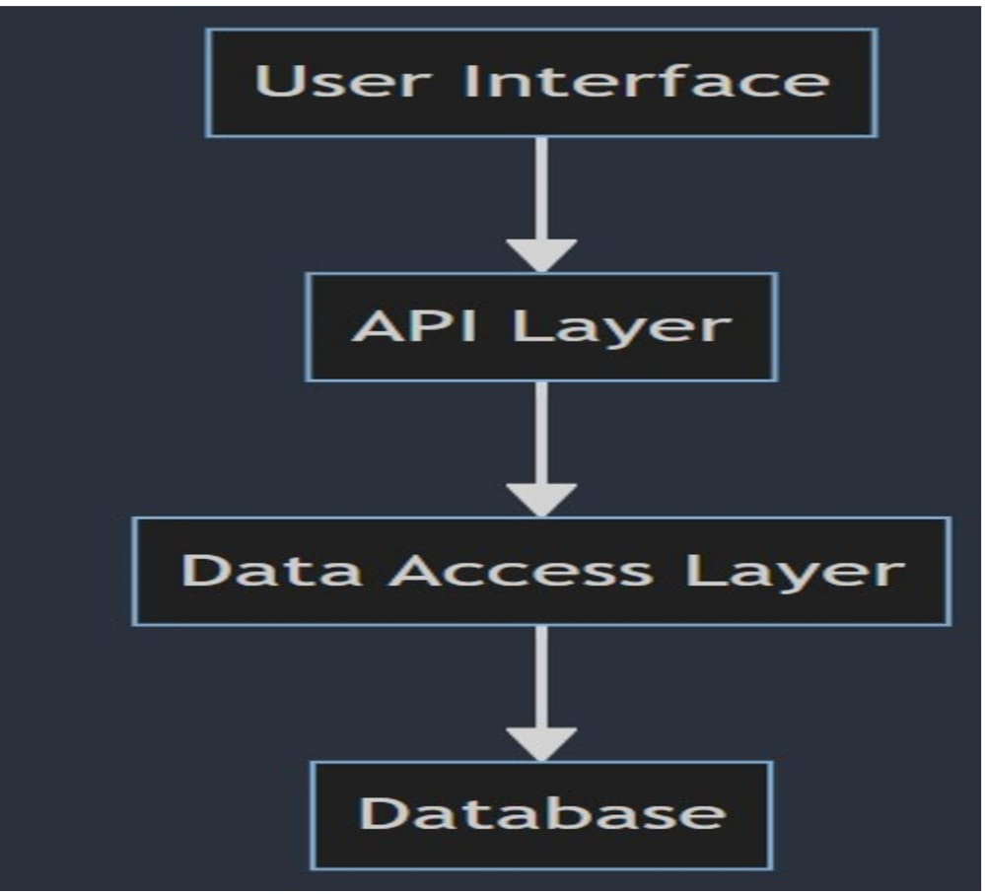

**Database Design of the Kabarak Finance System**

The database design of the Kabarak Finance System is structured to efficiently store and manage all necessary data while ensuring data integrity and security. The database schema includes the following key tables:

- Users: Stores information about all users of the system, including students, faculty, and administrative staff. Key fields include user_id, name, email, role, and account_status.

- Transactions: Records all financial transactions processed by the system. Key fields include transaction_id, user_id, transaction_type, amount, date, and status.

- Accounts: Manages user account information, including balances and account statuses. Key fields include account_id, user_id, balance, and last_updated.

- Notifications: Stores system-generated notifications and alerts for users. Key fields include notification_id, user_id, message, date, and status.

- Historical_Transactions: Archives past financial transactions for audit and reporting purposes. Key fields include transaction_id, user_id, transaction_type, amount, date, and status.

**CONTEXT DIAGRAM**

The diagram below shows context diagram for Kabarak finance system

STUDENT

FINANCE

DEPERTMENT

IT SUPPORT

KABARAK FINANCE

SYSTEM

REPORTS &CONFIRM PAYMENTS

MAKES PAYMENTS &

ACCESS ACCOUNT

PROCESS PAYMENTS

MANAGE ACCOUNTS & GENERATE REPORTS

MANAGE ERRORS

REPORTS ERRORS

**CLASS DIAGRAM**

The diagram below shows class diagram for Kabarak finance system

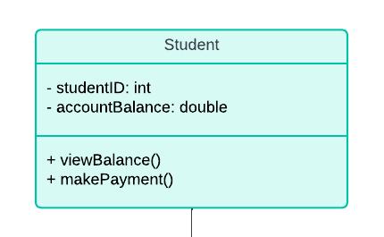

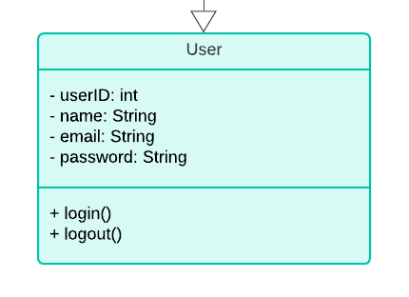

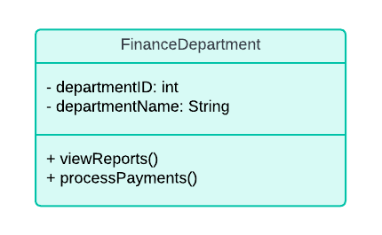

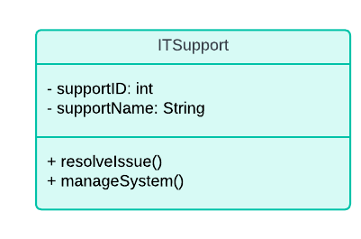

**USE CASE DIAGRAM**

The diagram below shows Use case diagram for Kabarak finance system

STUDENT

FINANCE MANAG

VIEW

BALANCE

MAKE

PAYEMENT

VIEW

REPORTS

PROCESS

PAYMENTS

RESOLVE

ISSUES

LOG IN

GENERATE

INVOICE

REPORT

ISSUE

**DATA FLOW DIAGRAM**

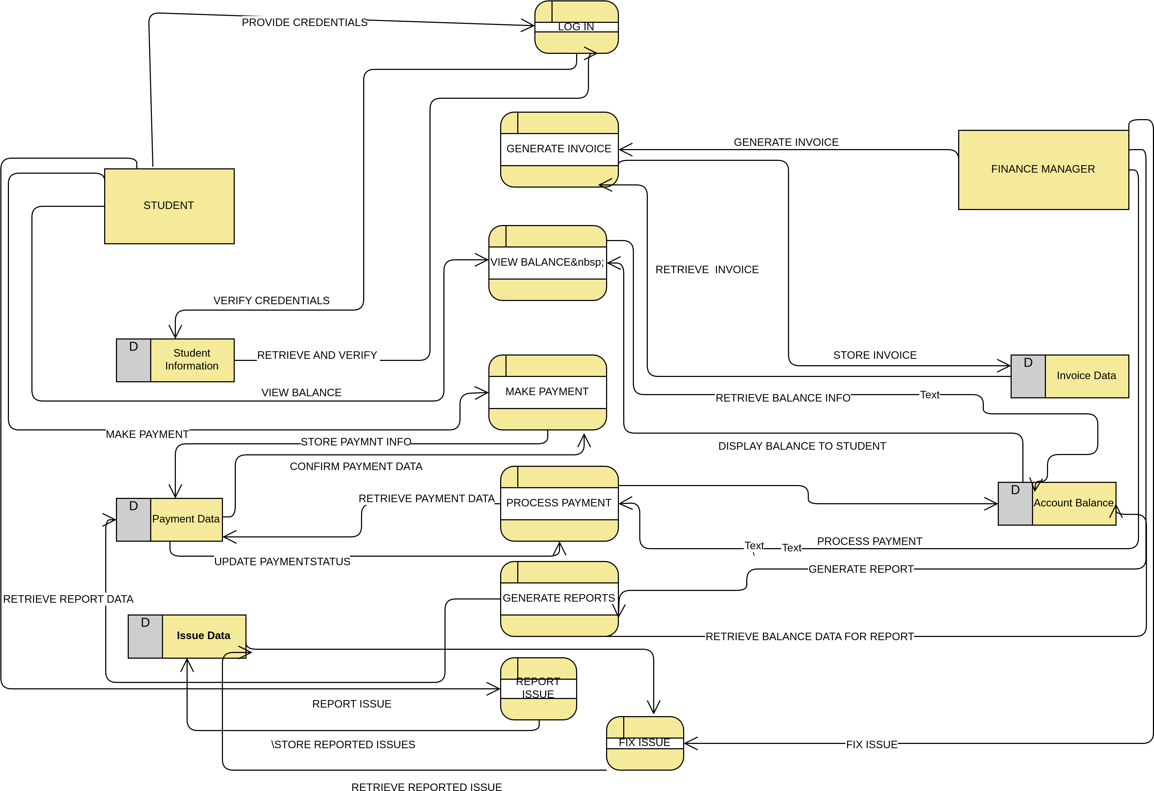

# 3.9 Ethical Considerations for the Kabarak Finance System

1. Data Privacy and Security

- Ensure the confidentiality of user data by implementing strong encryption and access controls.

- Regularly update security protocols to protect against data breaches and unauthorized access.

2. Transparency

- Provide clear and accurate financial information to all users.

- Maintain transparency in transaction processing and account management.

3. User Consent

- Obtain explicit consent from users before collecting or processing their data.

- Inform users about how their data will be used and stored.

4. Non-Discrimination

- Ensure equal access and services to all users, regardless of their status or background.

- Avoid any form of bias in transaction processing and financial services.

5. Accountability

- Establish mechanisms for users to report discrepancies or issues.

- Hold system administrators accountable for maintaining system integrity and ethical standards.

### **CHAPTER FOUR: SYSTEM IMPLEMENTATION AND DEPLOYMENT**

### **4.1 Introduction**

This chapter presents the implementation and deployment processes undertaken in the development of the **Kabarak Finance System**. It outlines the technical environment used, the step-by-step system development, the applied coding standards, and the testing and deployment strategies adopted to ensure a fully functional and reliable application.

The implementation process focused on building a secure, efficient, and responsive system that meets the financial management needs of Kabarak University. Emphasis was placed on developing a user-friendly front-end interface, integrating a secure and scalable backend, and connecting the application to a robust relational database.

In addition, quality assurance measures, including unit testing, integration testing, and usability testing, were performed to validate the system’s performance. The chapter also details the deployment plan and outlines the go-live strategy to transition the application from development to real-world usage. Post-deployment support and potential future enhancements are also discussed to ensure the long-term success and adaptability of the system.

### **4.2 Development Environment Setup**

The development of the **Kabarak Finance System** was carried out in a structured environment to ensure smooth implementation and testing.

#### **Hardware Used**

* **Processor**: Intel Core i5
* **RAM**: 8 GB
* **Storage**: 256 GB SSD
* **Internet**: Stable connection for testing and updates

#### **Software Tools**

* **Visual Studio Code** – Code editing
* **XAMPP** – Local development server (Apache & MySQL)
* **Google Chrome** – Browser testing
* **Postman** – API testing
* **Git & GitHub** – Version control
* **MySQL Workbench** – Database management
* **Figma** – UI/UX design

#### **Languages Used**

* **Frontend**: HTML, CSS, JavaScript
* **Backend**: PHP (planned Node.js support)
* **Database**: MySQL

The system was built and tested locally using XAMPP and deployed incrementally through GitHub, with Chrome Developer Tools aiding in front-end debugging and performance testing.

### **4.3 Implementation Steps**

The implementation of the Kabarak Finance System followed a modular approach, starting with the development of the user interface and gradually integrating backend logic and database operations. The system was built incrementally, with continuous feedback and testing after each phase.

#### **4.3.1 Front-End Development**

The front-end was developed using **HTML**, **CSS**, and **JavaScript** to create an intuitive, responsive, and user-friendly interface. Key features implemented in this stage include:

* **Login and registration screens**

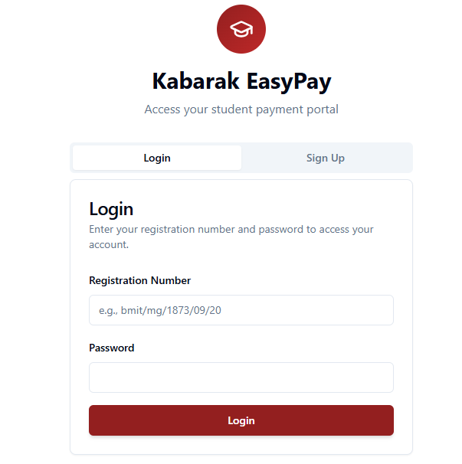

* **Dashboard for students and staff**

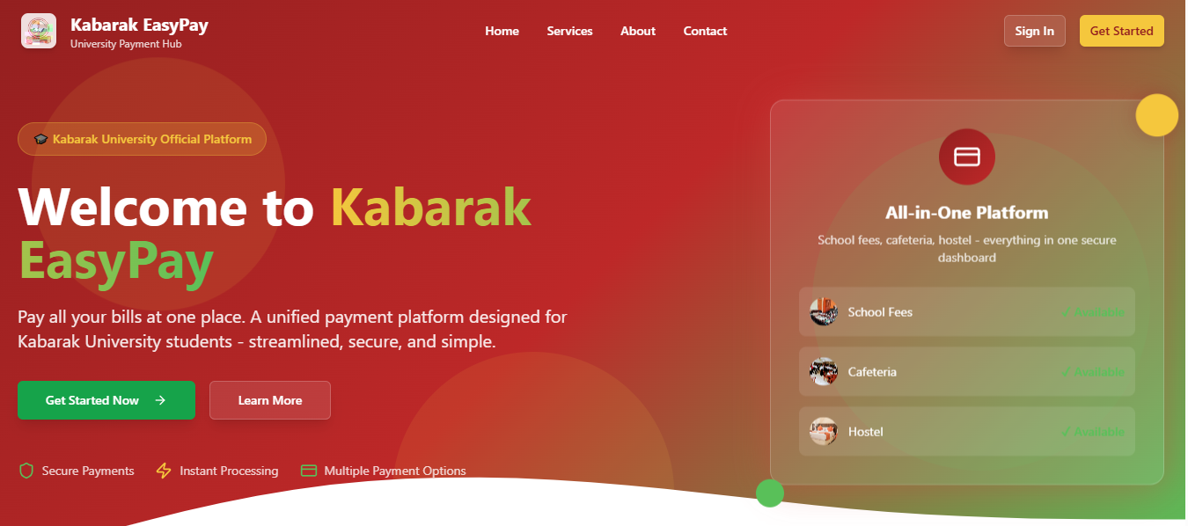

* **Transaction submission form**

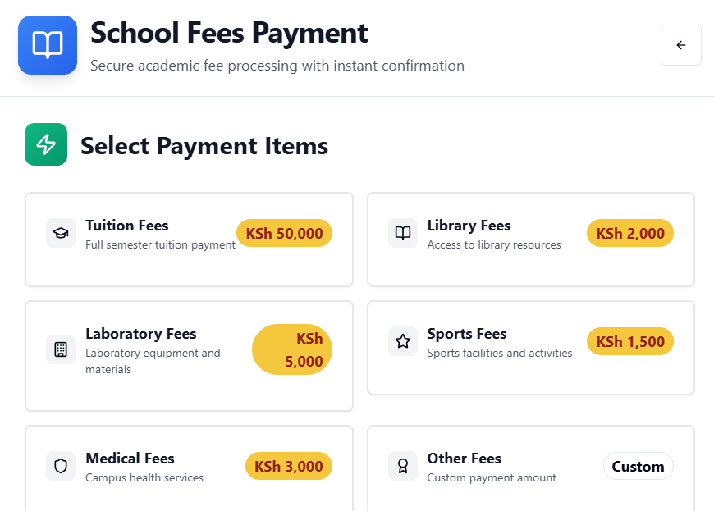



#### **4.3.2 Back-End Development**

While the backend is still under development, the plan is to use **PHP** (initially) for server-side scripting and **MySQL** for database interactions. The backend will handle:

* **User authentication and session management**
* **Transaction processing and validation**
* **Data retrieval and updates**
* **Notification logic**
* **Error handling and logging**

APIs will be introduced to support modular functionality and allow future integration with mobile apps or third-party systems like payment gateways.

#### **4.3.3 Coding Standards and Screenshots**

To ensure maintainability and readability, the following coding standards were followed:

* **Consistent naming conventions** (camelCase for JavaScript, snake_case for database)
* **Commented code** for clarity
* **Modular structure** with reusable components
* **Form validation** both on client and server side

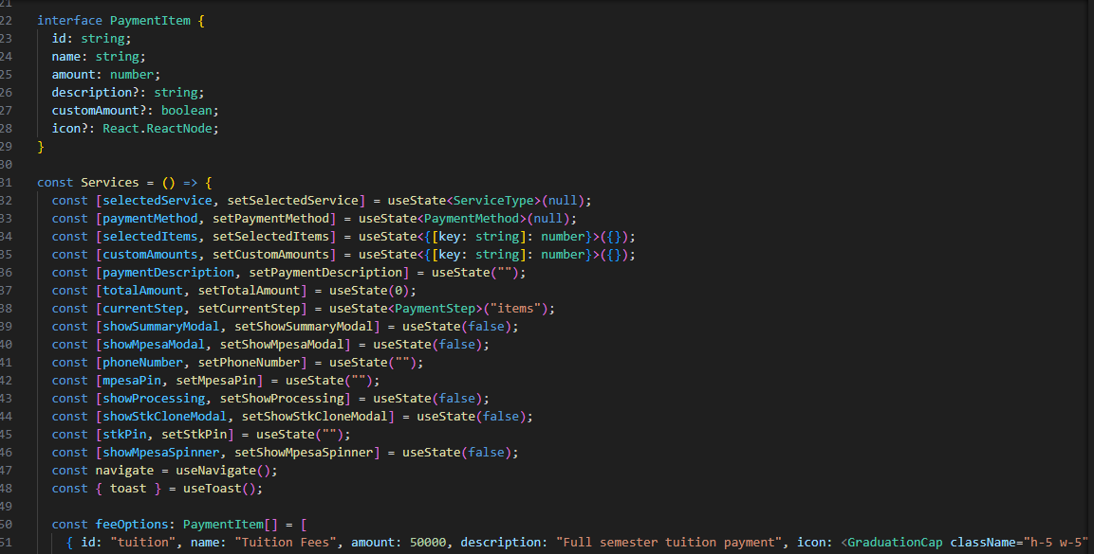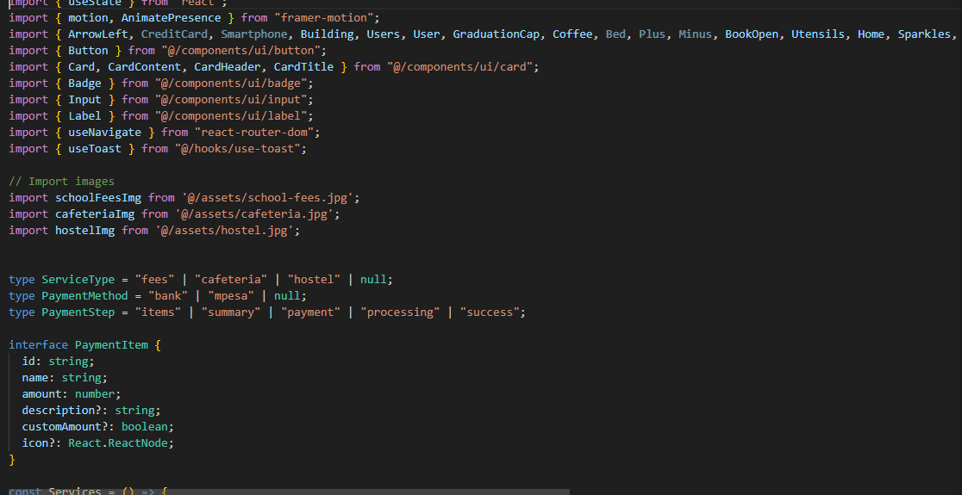

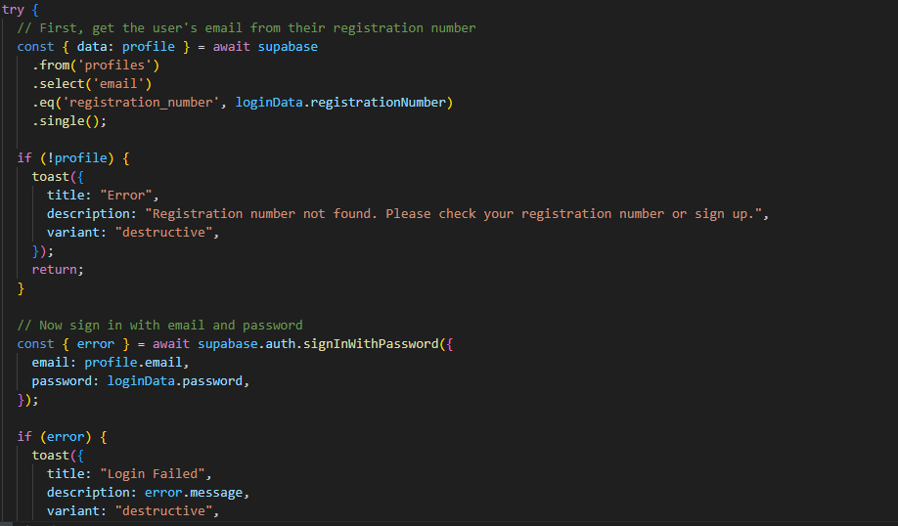

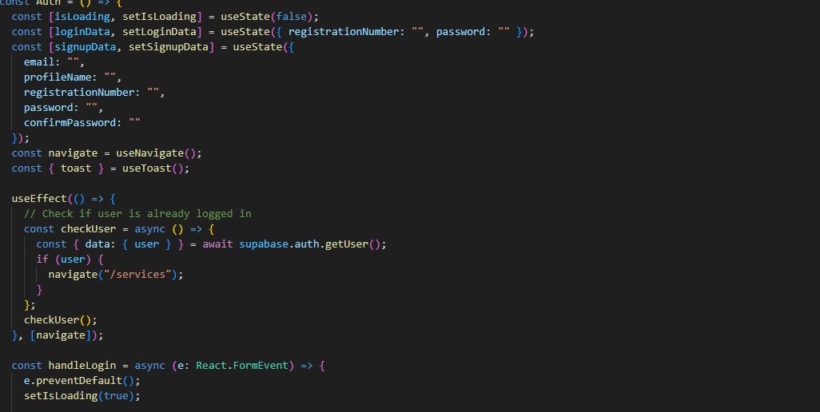

### **4.4 Testing and Quality Assurance**

To ensure system stability and correctness, several testing strategies and QA practices were employed during the development of the Kabarak Finance System.

#### **4.4.1 Testing Strategy**

The following types of testing were used:

* **Unit Testing**: Each function and module (e.g., login, payment, dashboard) was tested independently to verify correctness.
* **Integration Testing**: Combined components were tested to ensure smooth communication between the front-end, back-end, and database.
* **Usability Testing**: Real users, including students and finance staff, interacted with the system to provide feedback on layout, ease of use, and performance.
* **Cross-Browser Testing**: The application was tested across different web browsers (Chrome, Firefox, Edge) to confirm consistent appearance and behavior.

#### **4.4.2 QA Measures and Tools**

To maintain quality throughout development:

* **Bug tracking** was managed using GitHub Issues.
* **Postman** was used for testing backend endpoints and API responses.
* **Chrome DevTools** helped in front-end debugging and performance tuning.
* **Validation scripts** ensured form accuracy and prevented incomplete submissions.

Testing was continuous and incremental, aligned with the agile development process, allowing early detection and resolution of issues.

### **4.5 Deployment Plan**

The deployment of the Kabarak Finance System will follow a phased rollout:

1. **Pilot Testing**: A limited version will be deployed internally for testing by selected users (IT and finance staff).
2. **Feedback Collection**: Issues identified during pilot testing will be documented and addressed.
3. **Full Deployment**: After successful pilot validation, the system will be deployed university-wide via the student portal.

Deployment will use a shared server (initially through XAMPP) and may later migrate to a cloud-based hosting service for scalability.

### **4.6 Go-Live Plan**

The go-live plan includes:

* **Training sessions** for finance staff and helpdesk teams
* **User manuals and walkthroughs** for students
* **Backup and recovery plans** in case of system errors
* **On-site IT support** during the launch week

The system will go live during a low-activity period (e.g., semester break) to minimize operational disruptions.

### **4.7 Maintenance and Support**

Post-deployment, the system will enter a maintenance phase:

* **Continuous Monitoring**: Performance and error logs will be monitored.
* **User Feedback Collection**: A feedback form will be embedded for ongoing suggestions.
* **System Updates**: Minor patches and major updates will be released based on new requirements or bug reports.
* **Documentation**: Developer and user documentation will be kept updated.

Support will be offered through the university’s IT department.

### **4.8 Conclusion and Future Work**

The Kabarak Finance System is a step toward digital transformation at Kabarak University, improving the efficiency, accessibility, and security of financial services. Through thoughtful design, modular development, and rigorous testing, the system addresses core user pain points and sets a foundation for future expansion.

**Future enhancements** may include:

* Full **mobile app integration**
* Support for **multiple payment methods** (e.g., M-Pesa, bank)
* **Real-time analytics** dashboards for staff
* **AI-driven insights** to predict fee default trends or peak payment times

These upgrades will ensure the system remains relevant, scalable, and aligned with evolving user expectations.

### **CHAPTER FIVE: SUMMARY, CONCLUSION AND RECOMMENDATIONS**

#### **5.1 Introduction**

This chapter provides a summary of the entire project, drawing conclusions based on the findings and offering recommendations for future system improvements. It also outlines possible directions for future work that could further enhance the Kabarak Finance System’s functionality and scalability. The chapter consolidates the key insights obtained through research, design, implementation, and evaluation of the system.

#### **5.2 Summary of Key Findings**

The Kabarak Finance System was designed to address significant challenges in the current financial management infrastructure at Kabarak University. These included delays in transaction processing, frequent system errors, lack of mobile accessibility, and limited transparency in financial reporting.

The research revealed several critical insights:

* **Inefficiencies in the Existing System**: The manual system often led to long queues, slow updates, and frustrated students. IT and finance staff also reported recurrent issues that consumed time and resources.
* **User-Centered Design is Critical**: Interviews and feedback sessions with students and staff highlighted the importance of a user-friendly interface. The new system was built using HTML, CSS, and JavaScript to offer a responsive and intuitive front-end experience.
* **Security is a Top Concern**: Stakeholders emphasized the importance of protecting financial data. The system incorporates secure login, two-step verification, and encrypted data handling to mitigate the risk of fraud and unauthorized access.
* **Real-Time Capabilities and Automation**: Automation of transactions and real-time updates have significantly improved accuracy and reduced the administrative burden, as noted during usability testing and pilot evaluations.
* **Scalable and Modular Architecture**: The architecture was designed with future enhancements in mind, using modular code and APIs to enable easy integration of new features or third-party services like mobile money platforms.

#### **5.3 Conclusion**

The implementation of the Kabarak Finance System marks a significant milestone in the university’s digital transformation journey. The system successfully addresses the major drawbacks of the former financial management system by enhancing speed, accuracy, accessibility, and transparency.

By adopting an Agile development methodology, the project was completed in iterative cycles with continuous feedback from end users. As a result, the system was able to evolve based on real needs and practical challenges experienced by both students and administrators.

The Kabarak Finance System has proven to be a functional and impactful solution that not only improves daily operations but also fosters accountability and data integrity. The project further demonstrates the practical application of theoretical knowledge in building solutions that solve real-world problems in higher education institutions.

#### **5.4 Recommendations**

Based on the research findings and implementation experience, the following recommendations are made:

1. **Adopt the System Institution-Wide**  
   The university should consider integrating the Kabarak Finance System into the student portal and deploying it across all departments. Full adoption will maximize its benefits and streamline operations.
2. **Invest in Staff Training and Change Management**  
   Conduct regular training sessions for finance and IT staff to ensure smooth operation and maintenance of the system. A well-managed transition will reduce resistance and enhance user acceptance.
3. **Regularly Update Security Protocols**  
   With evolving cybersecurity threats, it is crucial to continuously update the system's security mechanisms. This includes applying patches, upgrading encryption techniques, and monitoring access logs.
4. **Enhance Mobile Accessibility**  
   Given the widespread use of smartphones among students, a dedicated mobile app or improved mobile version of the system would further enhance accessibility and user experience.
5. **Integrate with External Payment Systems**  
   Integration with mobile payment platforms such as M-Pesa, bank transfers, and debit cards will enable more flexible payment options for students and reduce reliance on in-person transactions.
6. **Establish a Support Desk**  
   Setting up a helpdesk or ticketing system within the application will allow users to report issues or request support directly, improving communication and system reliability.

#### **5.5 Suggestions for Future Work**

While the current system serves the core functions effectively, there is significant potential for future enhancements, including:

* **Development of a Mobile Application**: A native mobile app for Android and iOS will offer a better user experience than responsive web design alone.
* **Advanced Analytics Dashboard**: Real-time dashboards for finance staff could present data visualizations and trend analysis for budgeting, forecasting, and reporting.
* **AI-Powered Notifications and Predictions**: Integrating artificial intelligence could enable predictive alerts for late payments, fraud detection, or automated fee reminders.
* **Multi-Language Support**: Adding support for additional languages will make the system more inclusive, particularly for international students.
* **Feedback System and Chatbot Support**: A built-in feedback module and chatbot can improve user interaction and automate common support queries.

### **REFERENCES**

Fiawoo, M. A., Abakah, E. M., & Owusu-Acheaw, M. (2021). Assessing the effectiveness of e-payment systems in tertiary institutions: A Ghanaian perspective. International Journal of Scientific and Research Publications, 11(3), 150–159. <https://doi.org/10.29322/IJSRP.11.03.2021.p11123>

Kyaw Zay Oo, M. (2019). The application of two-factor authentication in secure e-payment systems. International Journal of Computer Applications, 177(24), 1–5. <https://doi.org/10.5120/ijca2019919681>

Moertini, V. S., Surendro, K., & Suhartono, D. (2011). A design framework for developing online tuition payment systems: A case study in Indonesian universities. Journal of Information Systems Education, 22(4), 359–370.

Nielsen, J. (1994). Usability engineering. Academic Press.

Nyamiaka, J. (2015). Adoption of e-payment systems in universities in Kenya: A case study of the University of Nairobi. International Journal of Scientific and Technology Research, 4(7), 291–298.

Salim, A. H. (2023). Digital transformation in university finance systems: The case for automation. Journal of Education Technology and Policy, 7(1), 44–58.

Solat, S. M. (2017). Security risks in e-payment systems: Analysis and mitigation strategies. Journal of Information Security and Applications, 32, 29–37. <https://doi.org/10.1016/j.jisa.2017.03.004>

Yang, X., & Wen, J. (2020). Responsive web design principles for university student portals. Journal of Web Engineering and Technology, 8(2), 100–116.

**APPENDICES**

Appendix I: Budget

Item Description Estimated Cost (KES)

Laptop (existing) Used for development 0

Internet Access Data bundles for research & testing 3,000

Software Tools Free (VS Code, XAMPP, MySQL Workbench, Figma) 0

Hosting (shared/local via XAMPP) Local server for development/testing 0

Printing & Documentation Hard copies for submission 1,000

Contingency Miscellaneous costs 1,000

Total Estimated Cost 5,000 KES

Appendix II: Data Collection Tools

1. Survey Questions for Students

How often do you use the current financial system?

What challenges have you experienced when making payments?

Do you prefer mobile access for financial transactions?

Rate your satisfaction with the current system (1–5).

2. Interview Guide (Finance Staff & ICT Department)

What are the main problems with the current system?

What features would be helpful in a new system?

How often do you deal with student complaints regarding payments?

What reports or analytics do you frequently need?

Appendix III: Project Schedule (Gantt Chart)

Activity Jan Feb Mar Apr May June July

Project Proposal ✅

Requirement Gathering ✅

System Design (UI/DB) ✅ ✅

Development (Frontend) ✅ ✅

Backend Setup (PHP/MySQL) ✅ ✅

Testing & QA ✅ ✅

Documentation & Report ✅ ✅

Final Presentation & S